**User Documentation: Logging in to the Webpage**

**Introduction**:

Welcome to our webpage! This documentation will guide you through the process of logging in to access the features and functionalities.

Getting Started:

To access the webpage, follow these steps:

Open your preferred web browser.

Enter the following URL in the address bar: https://192.168.1.4:5005/?machine_ids=plodder_1_a

Press Enter to navigate to the webpage.

Logging In:

Upon reaching the webpage, you will be directed to the login page.

**Login Page** :

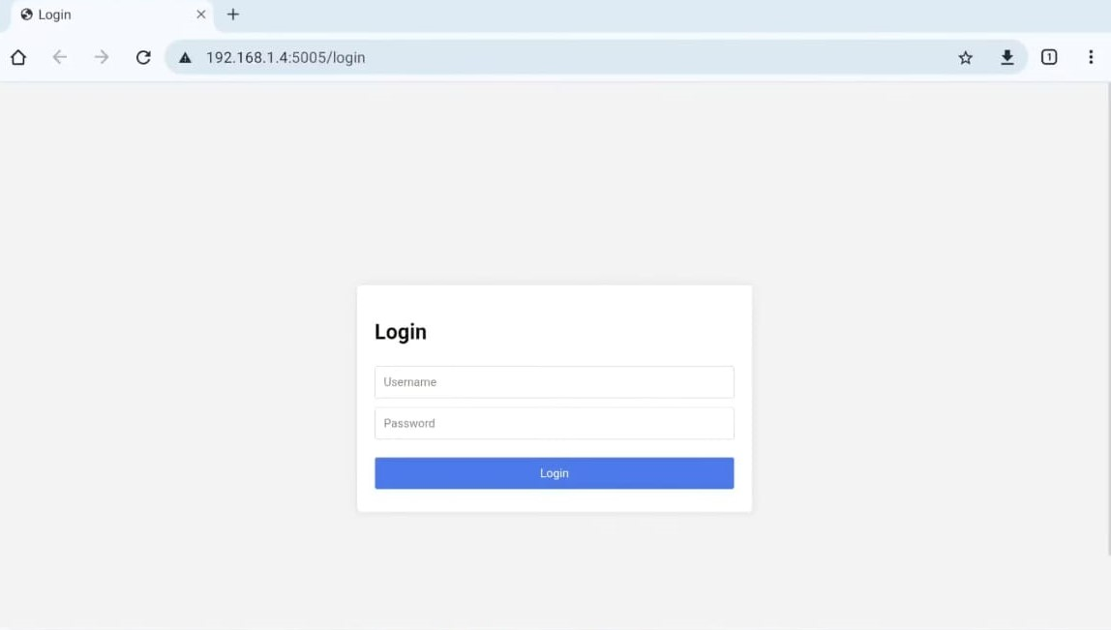

Enter your username and password in the designated fields.

Click the "Login" button to proceed.

Username and Password:

Ensure you enter the correct username and password provided to you.

**Troubleshooting:**

**If you encounter any issues during login, ensure that:**

You have entered the correct username and password.

Your Network connection is stable.

The webpage URL is entered correctly.

If problems persist, contact our support team at [**support@example.com**](mailto:support@example.com)**.**

**User Roles and Permissions**

**Introduction:**

Our webpage provides different levels of access based on your user role. This documentation outlines the permissions and capabilities associated with each role.

**User Roles:**

**Admin:** Admin users have full access to all features and functionalities of the webpage. They can make changes to any aspect of the webpage.

**Admin Home Page :**

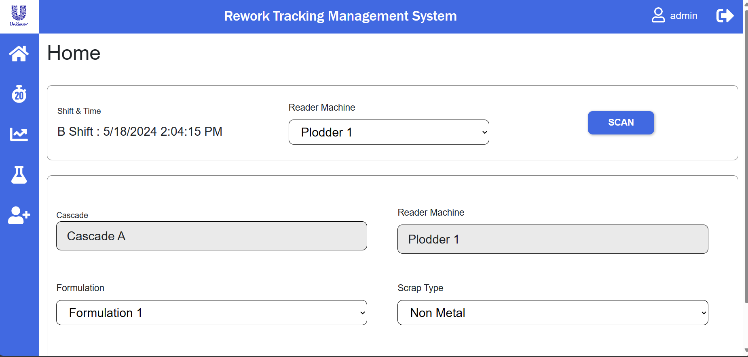

As Admin, User can able to change the Formulation and Scrap Type fields Data, Remaining all fields are default. Even Admin can’t able to change those fields. After Selecting the options from Formulation and Scrap Type User click on submit button.

**Home Page With Submit Button :**

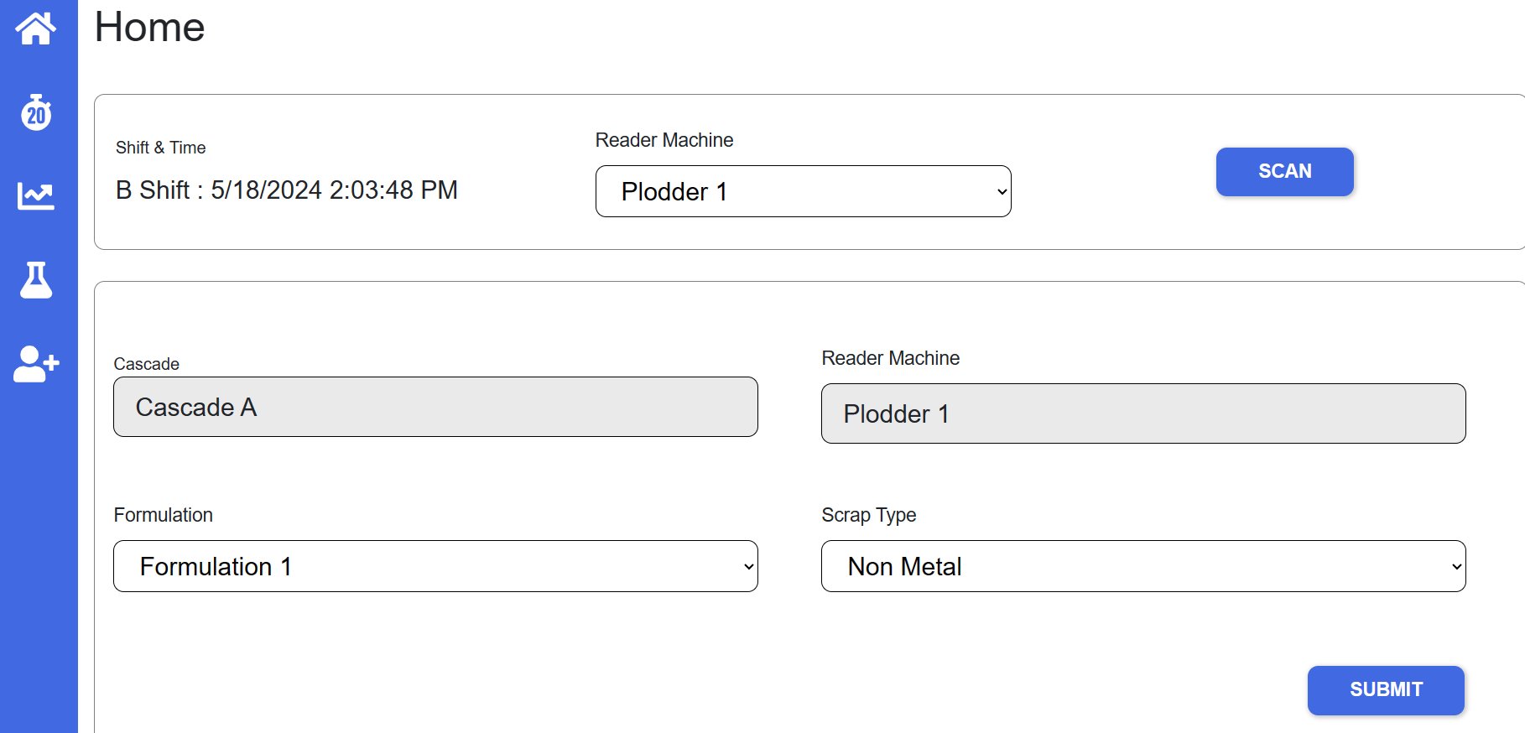

After Clicking on submit button user will click on Scan Button, it will be redirected to Scanning Tags Page.

**Scanning Tags Page** :

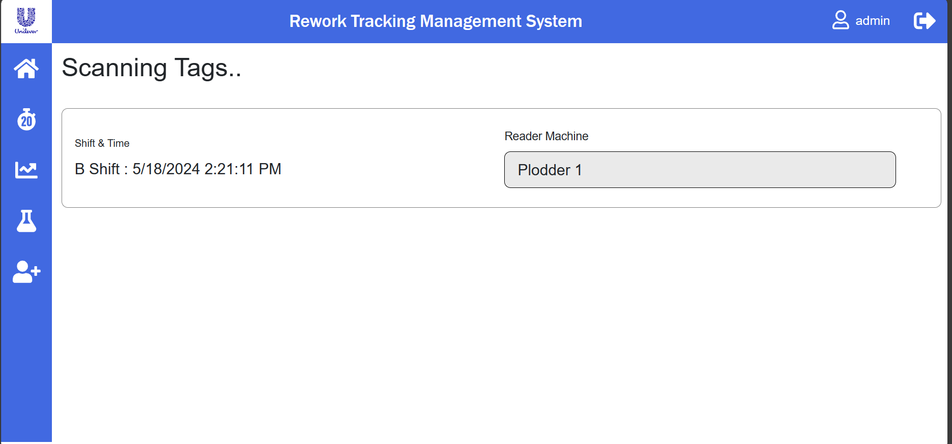

Now there is no tags on this page, If tags are scanned at the reader then tags will be displayed in this page only. After tags displayed page will be look like this

**After Tags Scanned Scanning Tags Page :**

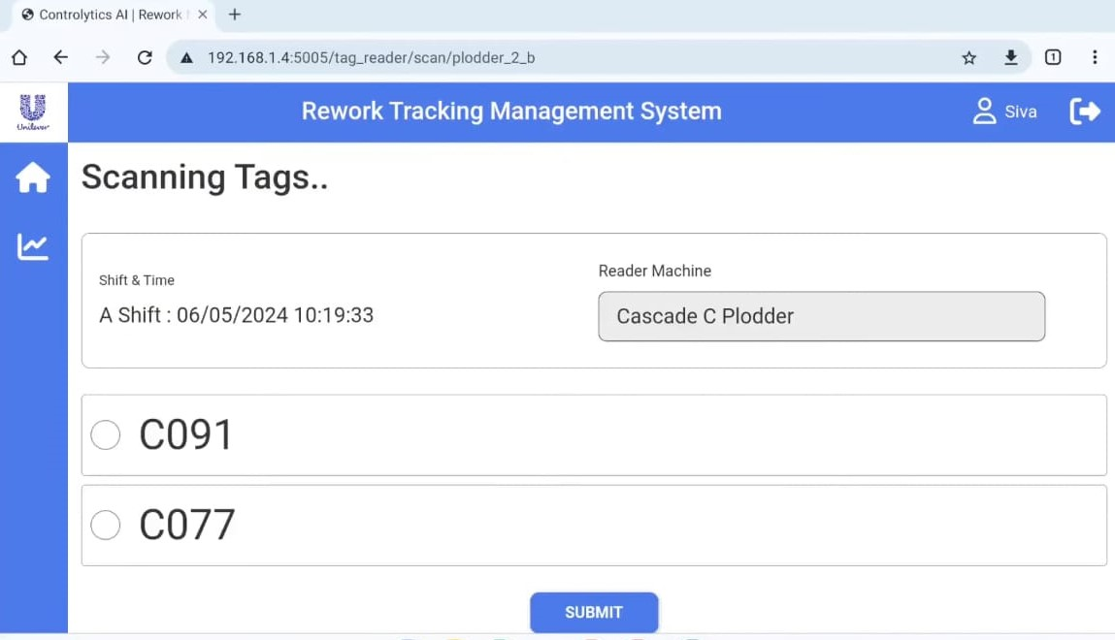

On above Image C091 & C077 are tags. Like that scanned tags will be displayed on this page.but user select only one tag.more than one tag couldn’t be submitted. After selecting one tag user click on submit button, then that tag name and formulation and scrap type data also submitted. When user submitting tag it will show formulation name,scrap type and tag name information.

**Tags Information** :

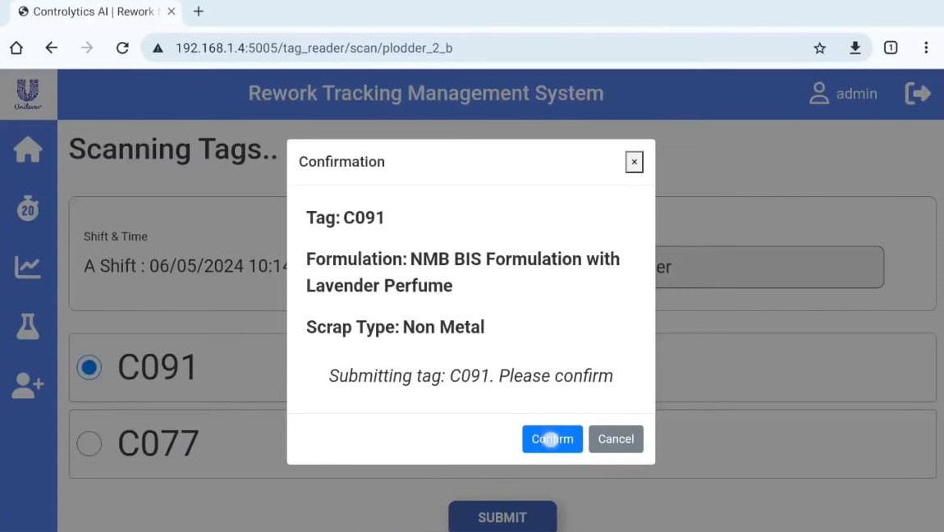

If user clicks on confirm then data will be submitted. If user clicks on cancel scanned tags will be displayed.If that tag is already added it’ll ask for confirmation.if it comes as already mappe,user clicks on confirm then tag data and everything will be overwritten.

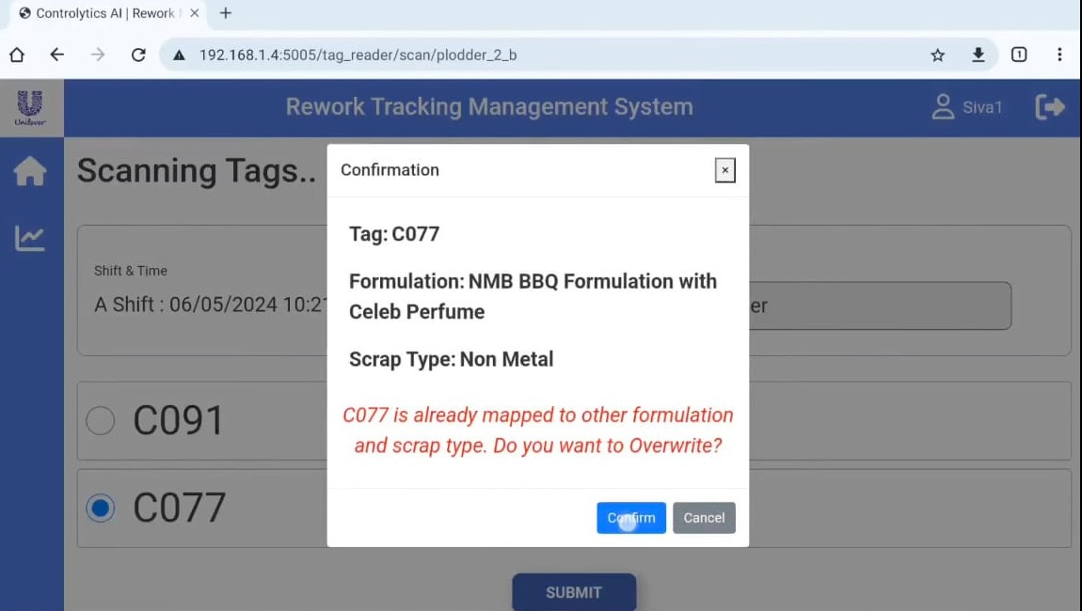

**Running Batch Page :** Running Batch only access for Admin.

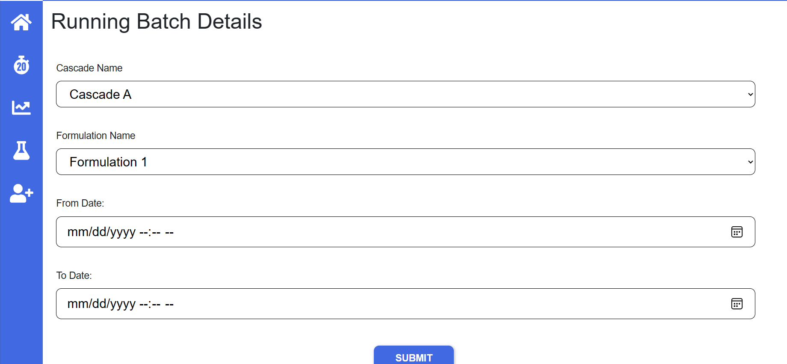

Running Batch page is linked with clock symbol icon. User Click on 20 symbol logo then running batch page will be open. Here on this page User can select options in Cascade Name, Formulation Name, From Date and To Date. After selecting each one option from each field then click on Submit button.Now Running Batch is automatically started.Once Batch is Started then it looks like this

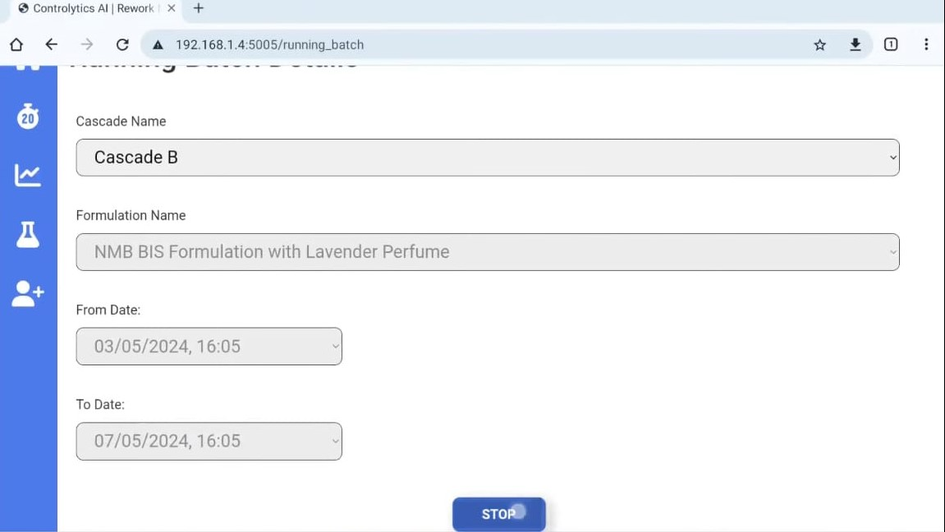

After Batch started all fields can’t be change until user clicks on Stop button.User Can change the Cascade Name.If user need to change the current running batch then user need to stop the current running batch and create the new batch.

**Reports Page :**

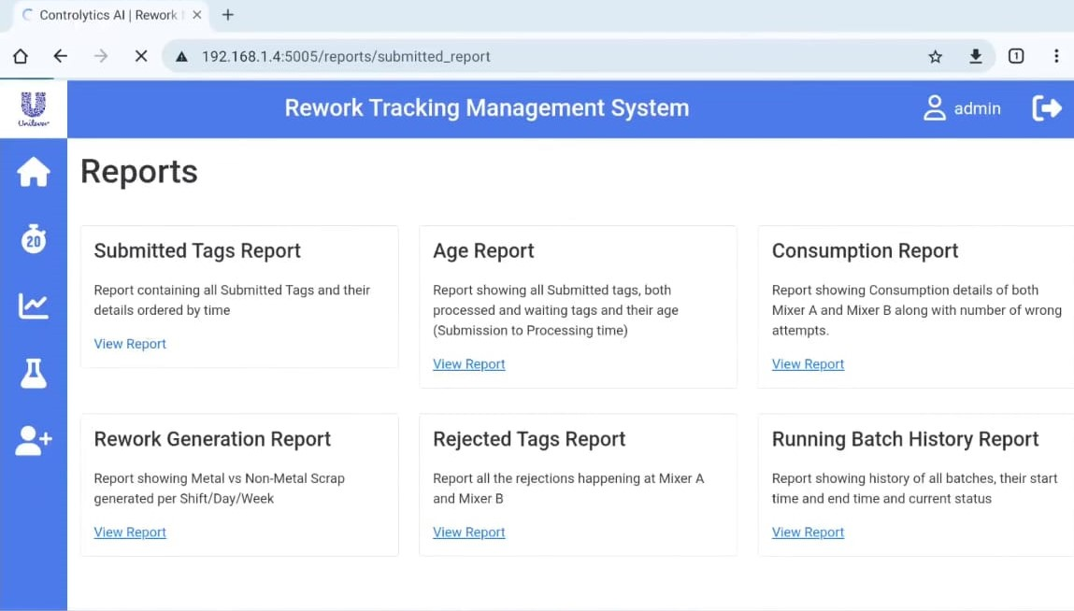

In this page, we see all the reports pages.

**Submitted Tags Report :**

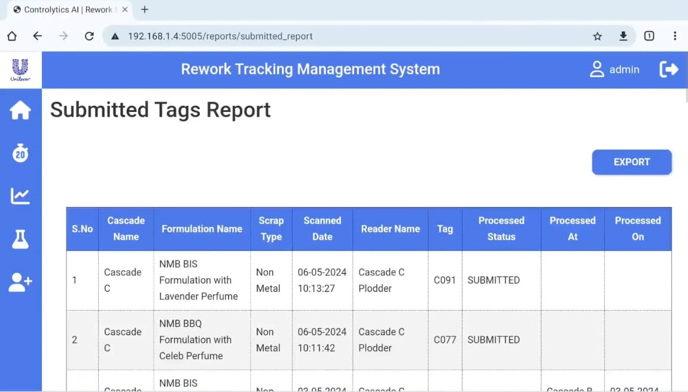

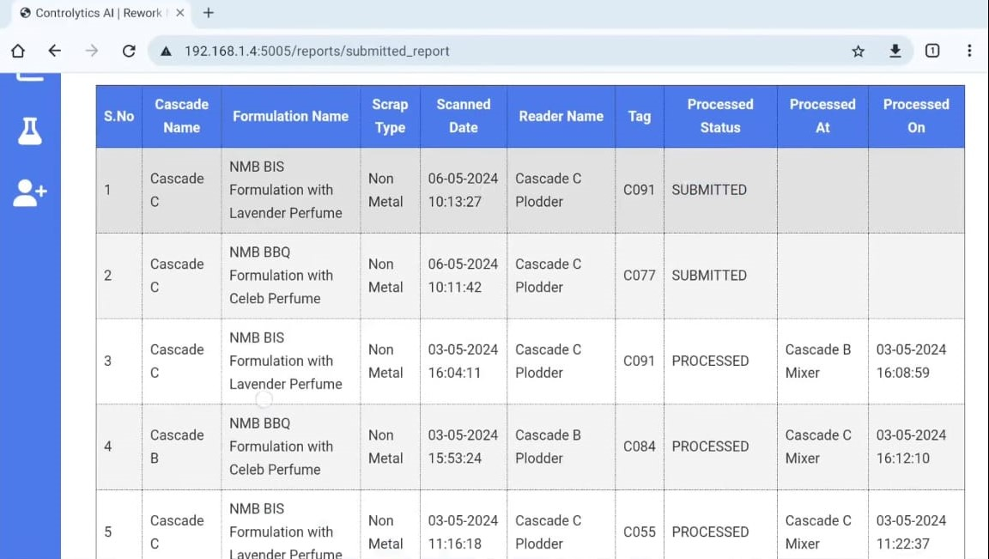

All the Submitted Data will be displayed in this Report. And here we can see export button,when user click on that button then report file will downloaded as Excel file in Local HMI.

**Age Report :**

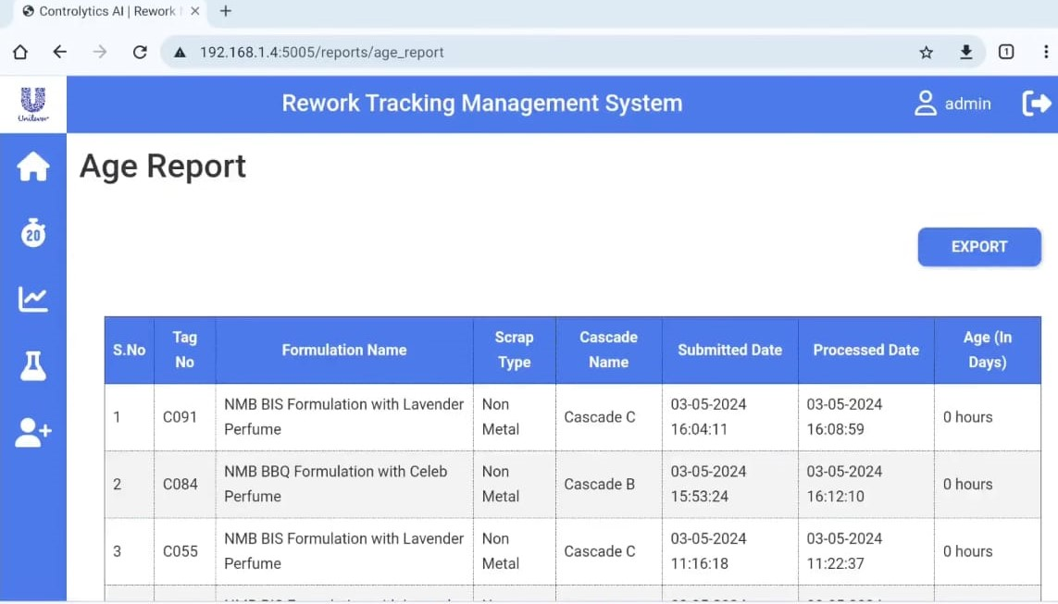

**Consumption Report :**

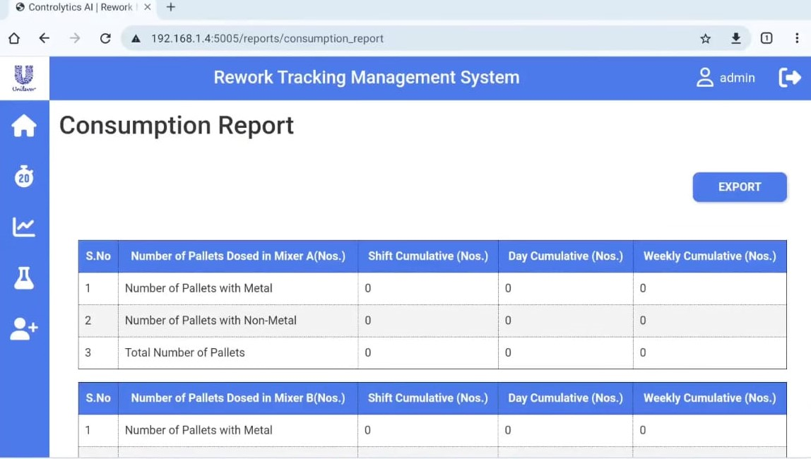

**Rework Generation Report :**

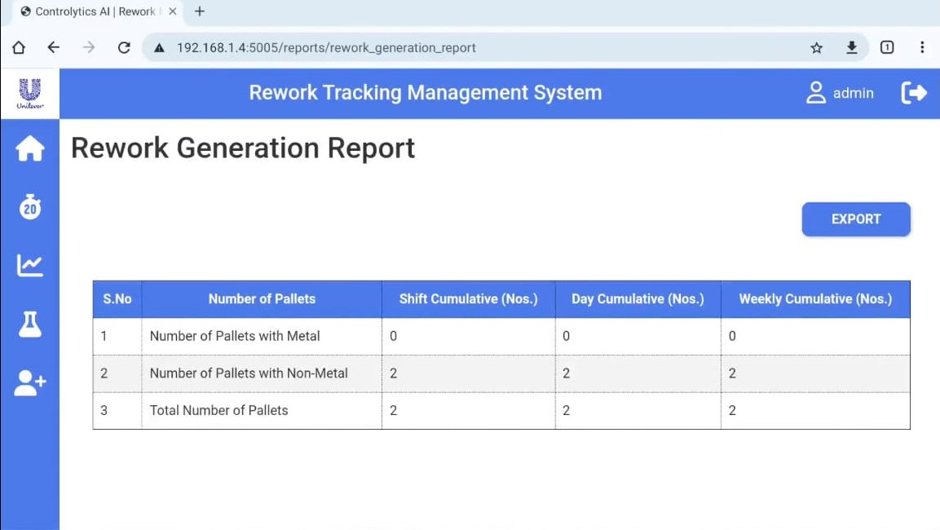

**Reject Tags Report :**

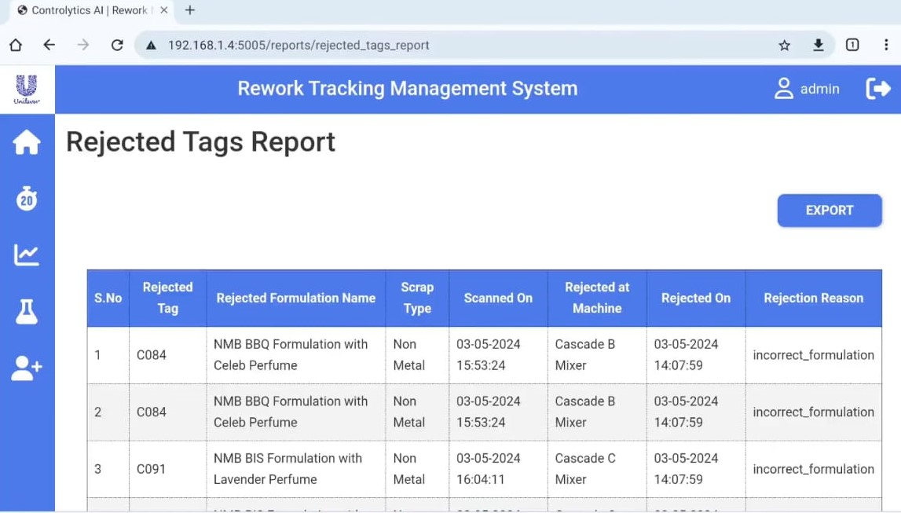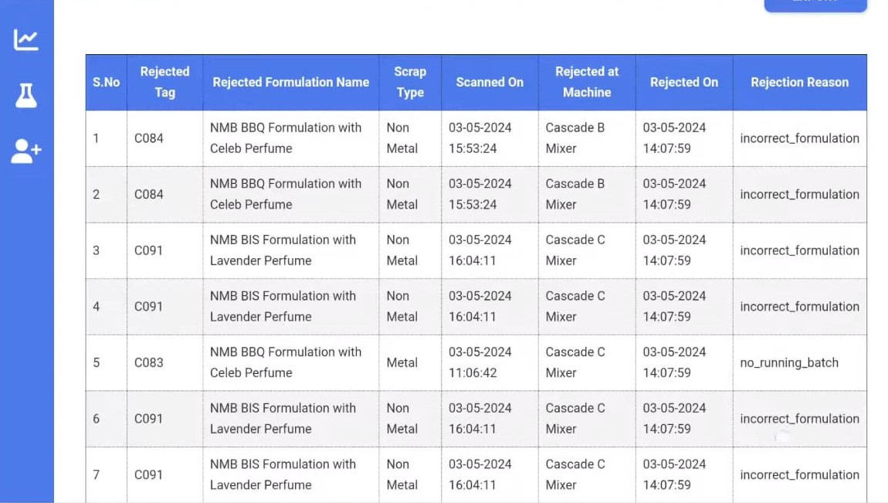

In this report, we can see which tags are rejected by mixer readers,those data will be displayed in this report and also it will show reason for rejection.

**Running Batch History Report :**

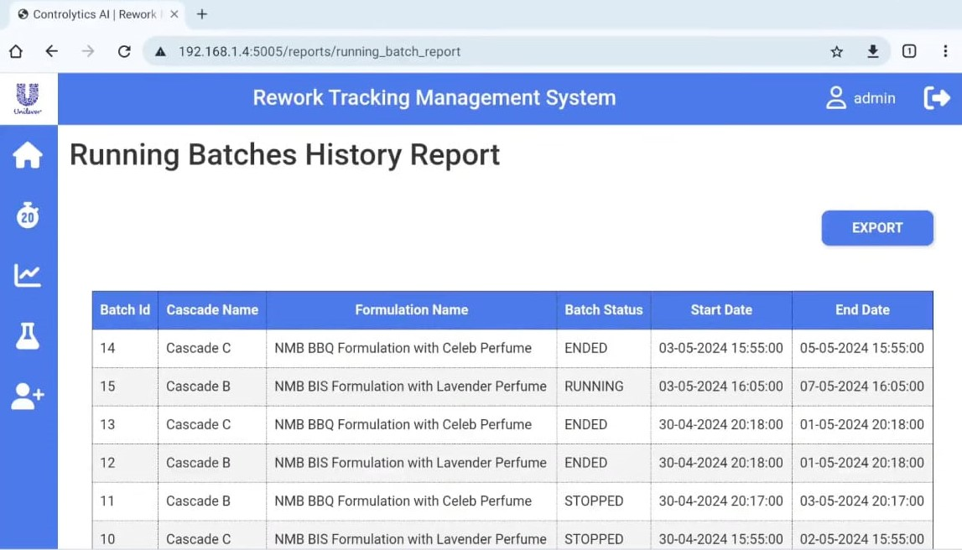

**In** this report we can see the Running Batch status, and all the batches history and status her.Reports will be available for all types of users like Admin,Operator,Supervisor.

**Formulation Adding :**

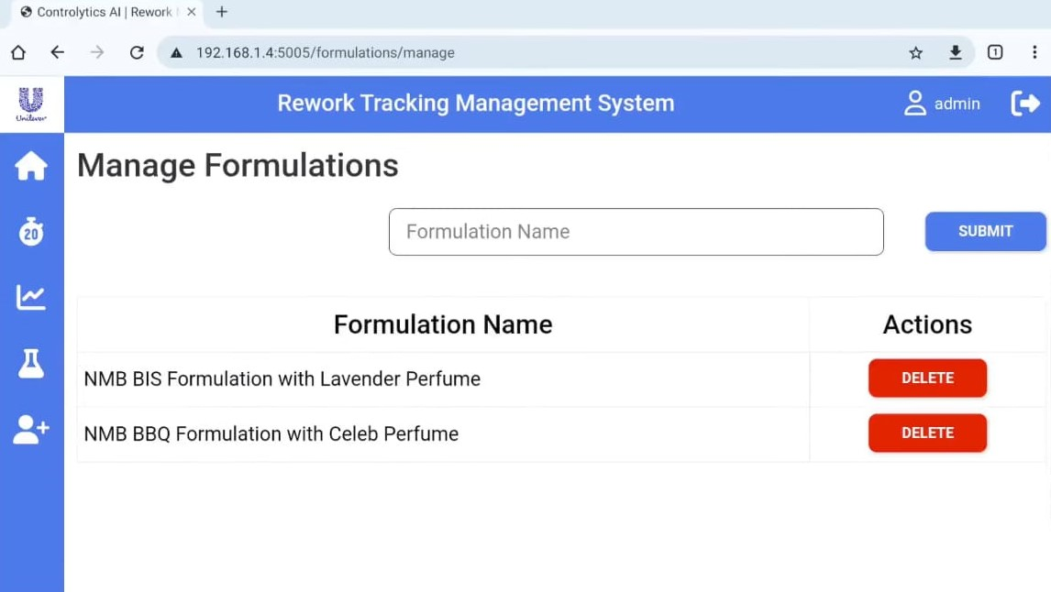

In this page we can add new formulations,On input field enter formulation name and click on submit button. Then that formulation will be added in home page and running batch pages.Added formulation will be displayed like in the above image.

**Adding Users :**

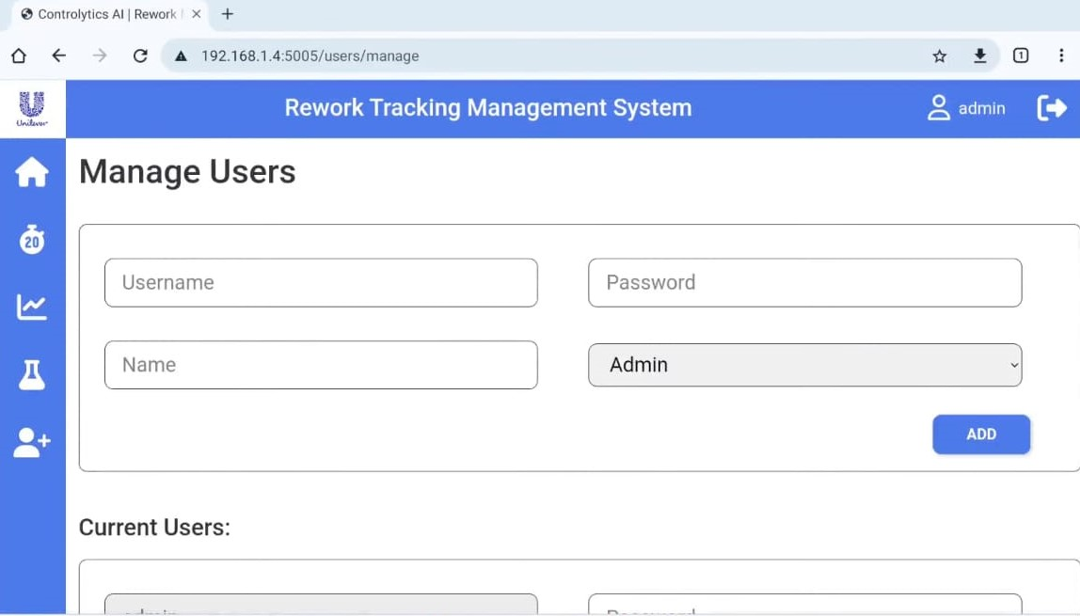

Here we can add new users. Enter user name,password,name and select the user type like admin,operator and supervisor after that click on add then new user will be created.all the users list will be shown in the current users section. After creating new user name and password,user can login with that new credentials.

**Supervisor:** Supervisor users have restricted access compared to admins. They can only change the scrap type on the webpage.

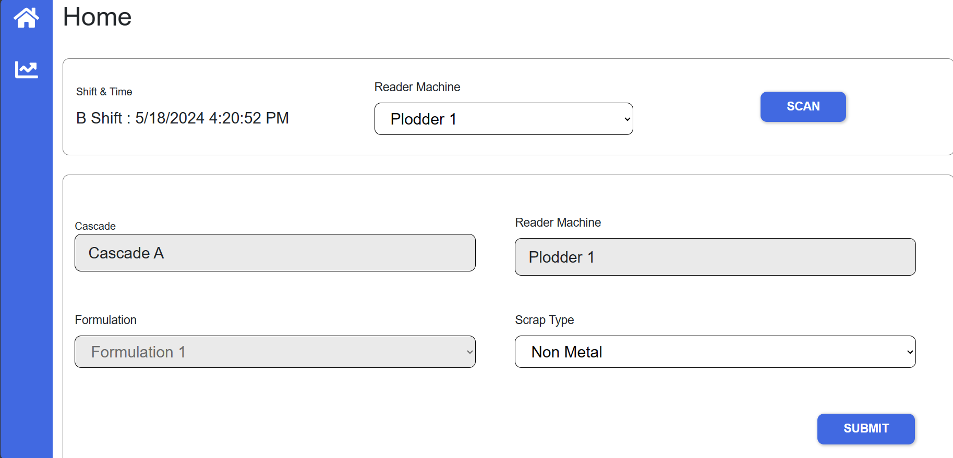

Supervisor Can only change the Scrap Type and submit.Remaining all features are disabled for supervisor,User only have access for submitting the data and to see the reports.

**Operator:** Operator users have the most limited access. They cannot make any changes to the webpage.

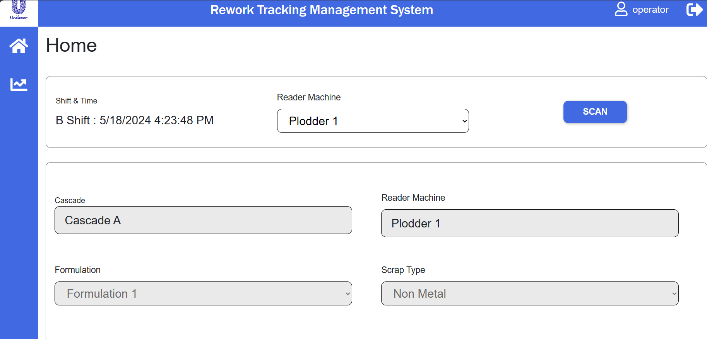

Operator can only scan and submit the tags data and also operator can see the reports page.Remaining all the features are disabled for operator.

**Access and Permissions:**

**Here's a breakdown of the permissions associated with each user role:**

**Admin:**

Access to all features and options.

Can modify settings, content, and user permissions.

Has full control over the webpage.

**Supervisor:**

Access to limited features.

Can only change scrap type.

Cannot modify other settings or content.

**Operator:**

Limited access to view-only mode.

Cannot make any changes to the webpage.

Restricted to performing predefined actions without altering the webpage.

**Troubleshooting:**

**If you encounter any issues related to access or permissions, ensure:**

You are logged in with the correct user role.

Your account has the necessary permissions assigned.

Contact the admin for further assistance if needed.